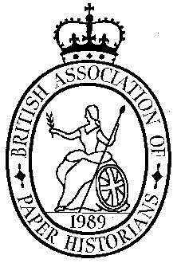
British Association
of Paper Historians

Visit to the College of Arms
Tuesday 29th September, 2026

At 2pm on the afternoon of Tuesday 29th September we have a rare opportunity to visit the College of Arms. The visit to this heraldic centre includes a short tour of the College Record Room Library and a visit to the Conservation Department. The visit will be led by Christopher Harvey and is limited to 15 people.

The College of Arms is on Queen Victoria Street, near St.Paul’s Cathedral.
Post Code EC4V 4BT

The nearest tube stations are Blackfriars, St Pauls, Mansion House.

Those travelling to London and requiring accommodation will find a selection of excellent hotels in the Holborn Area

The cost for the visit only will be £18 each for members and their partners and £25 for non-members. We need to know numbers so please book as soon as possible with:
Barbara Venables at bmvenables@gmail.com
or Phil Crockett at phil.crockett@btinternet.com
Final meeting details will be sent nearer the time.

To avoid collecting money on the day would you please send your cheque, payable to BAPH, before the meeting to:
Phil Crockett,
Littlefield, Christmas Common., OX49 5HR

You may also pay by Direct Transfer into the BAPH bank account using the following:
Sort Code: 20 39 53
Account No.: 80216127 (BAPH or British Association of Paper Historians)
Reference: PLEASE put your surname and initials – (essential!)

