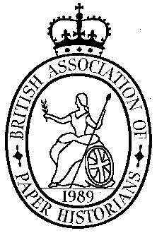
BAPH Autumn Meeting 2026

On Wednesday 30th September we shall hold the BAPH Autumn Meeting from 11.00am – 5.00pm in the Farringdon Room at the St Bride Foundation. The meeting will be similar to our Spring Meeting. We shall start at 11am with coffee and finish at 5pm with a complimentary glass of wine, there is a break for lunch when delegates can visit the local hostelries or bring sandwiches.
The speakers we have so far are:
Miquel Gutiérrez Poch: “The Paper Trade (1907) by A. Dykes Spicer”
Clare Taylor: ‘Embossed wallpapers imitating gilt leather, c.1880-1920’
Elaine Cooper:
Christopher Harvey:
Daven Chamberlain: Wood Panel Manufacture in UK

The St Bride Foundation is on Bride Lane, near Ludgate Circus, between Fleet Street and New Bridge Street. Post Code EC4Y 8EQ
The nearest tube stations are Blackfriars, St Pauls, Mansion House and Farringdon. More details may be found at: www.stbride.org/visit

Those travelling to London and requiring accommodation will find a selection of excellent hotels in the Holborn Area
If you plan to come please let us know:
Barbara Venables at bmvenables@gmail.com
or Phil Crockett at phil.crockett@btinternet.com
There is an administration charge for the day of £20 to members of BAPH and conservators and members of WHS, £27 to non-members and BAPH joint members. The wine is included. To avoid collecting money on the day would you please send your cheque, payable to BAPH, before the meeting to:
Phil Crockett,
Littlefield, Christmas Common., OX49 5HR

You may also pay by Direct Transfer into the BAPH bank account using the following:
Sort Code: 20 39 53
Account No.: 80216127 (BAPH or British Association of Paper Historians)
Reference: PLEASE put your surname and initials – (essential!)

