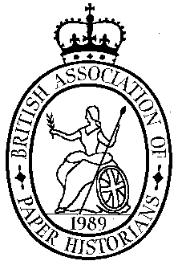

Spring Meeting 2026
Tuesday 3rd March 2026, 11.00am – 5.00pm

Once again we have booked the Farringdon Room at the St.Bride Foundation for our popular Spring Meeting. Please note this is a Tuesday not our customary Wednesday.
Holding the meeting on a weekday seems to work well for members and helps with cheaper train fares. We plan to start at 11am with coffee and finish at 5pm with a complimentary glass of wine, there is a break for lunch when delegates can visit the local hostelries or bring their own sandwiches. Our contributors are:

Peter Bower: Hercule Florence(1804-1879)- Unsung pioneer of photographic printing on paper
Penny Jenkins: Repair of a Print and Identifying a possible Rembrandt(provisional title)
Christopher Harvey: Conservation at the College of Arms – the craft of making & repair
Ellie Burkett: Paper as Canvas, Cloth and Thread - A textile artist's involvement in the
Japanese paper techniques of NE Japan
Kate Farley: Block, Rotate, Repeat – Other ways of printing designs on wallpaper & fabric
Alexander Romanov-Hughes: John Hutchinson – Australian Papermaker

Further information contact: Phil Crockett at phil.crockett@btinternet.com

The St Bride Foundation (Institute) is on Bride Lane, near Ludgate Circus, between Fleet Street and New Bridge Street.
The nearest tube stations are St Pauls, Farringdon and Chancery Lane and Blackfriars. More details may be found at: www.stbride.org/visit

There is an administration charge for the day of £20 to members of BAPH and conservators and members of WHS, £27 to non-members and BAPH joint members. The wine is included. To avoid collecting money on the day would you please send your cheque, payable to BAPH, before the meeting to:
Phil Crockett,
Littlefield, Christmas Common., OX49 5HR

You may also pay by Direct Transfer into the BAPH bank account using the following:
Sort Code: 20 39 53
Account No.: 80216127 (BAPH or British Association of Paper Historians)
Reference: PLEASE put your surname and initials – (essential!)

